Instructions on how to download Python and Hex code for Caeser Cipher
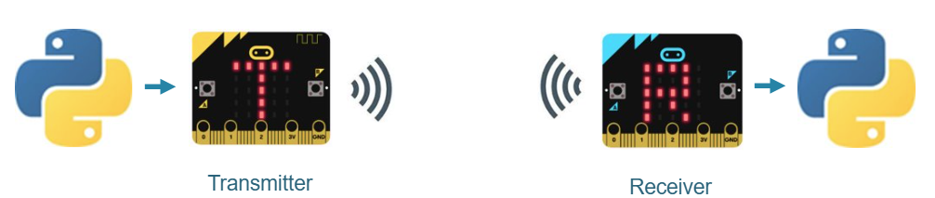
Python code is used to encrypt a message using a Caeser Cipher. The encrypted message is sent to a micro:bit i.e. the transmitter. This sends the message to a receiving micro:bit that in turn sends it to a Python script for decoding.
Requirements
- Two micro:bits (Transmitter and a receiver)
- Two computers: One computer to allow the user to encode a message that’s sent to the transmitter micro:bit and a second computer that will decode the message it will receive from the receiver micro:bit.


- Click on octocat to open GitHub repository with the code

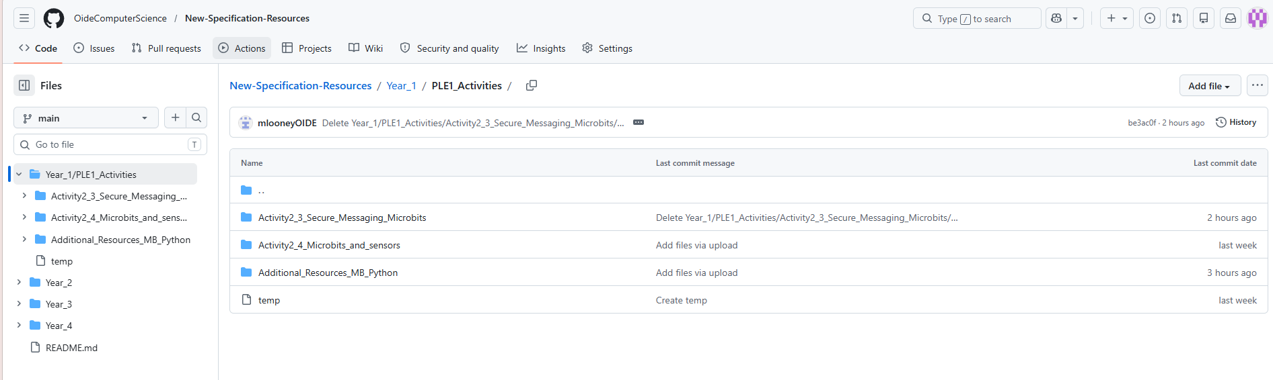
Click on folder to see hex and python code

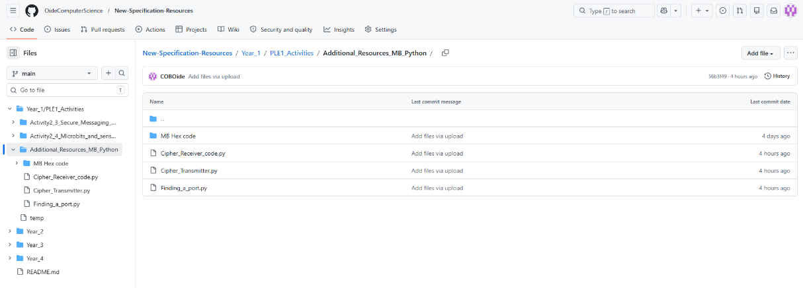
Click on python files and download
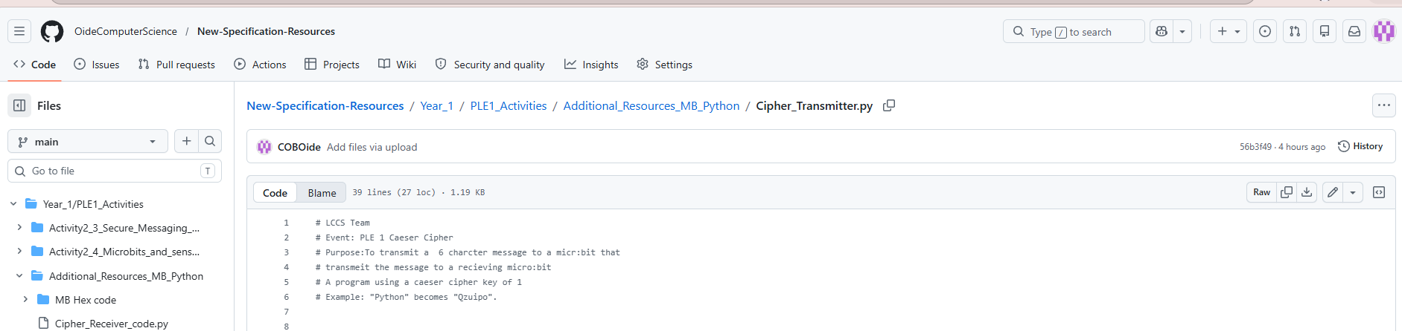

- Open and download the hex files for the micro:bit transmitter and receiver.
- Connect the transmitter micro:bit to the computer with the Cipher_Transmitter.py.
- Connect the receiver micro:bit to the computer with the Cipher_Receiver.py.
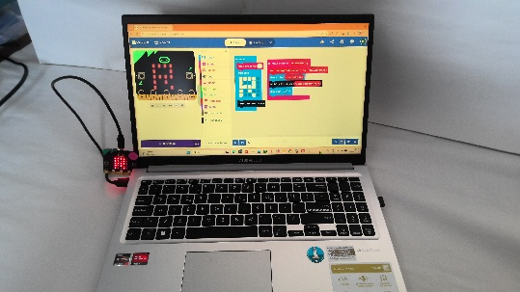
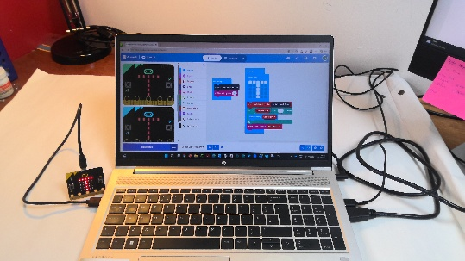

Transmitter and receiver setup

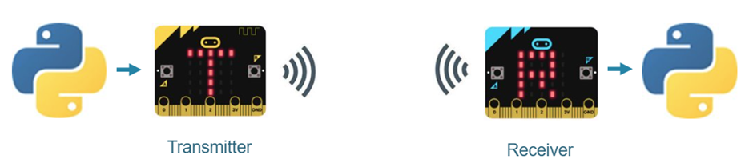

- Before running the above code run Finding_a_port.py. This will detect a connected BBC micro:bit and display its serial port information in the shell.
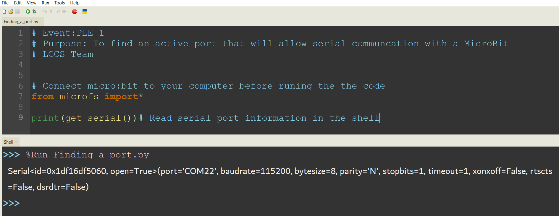

- Once the receiver code is running it will be Listening for MB messages …

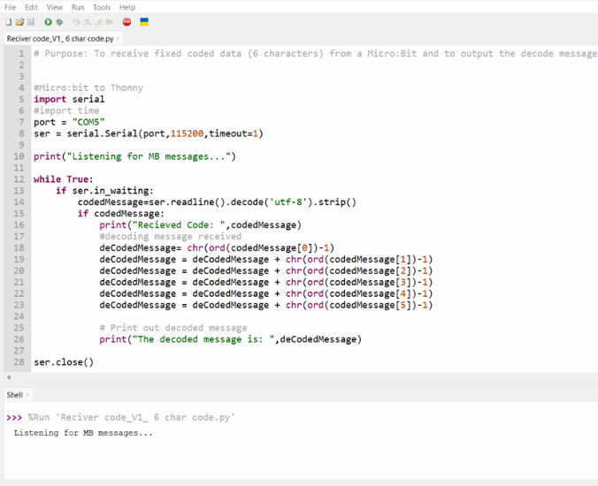

- Once the transmitter micro:bit has received a coded message it will transmit the message to the receiver micro:bit

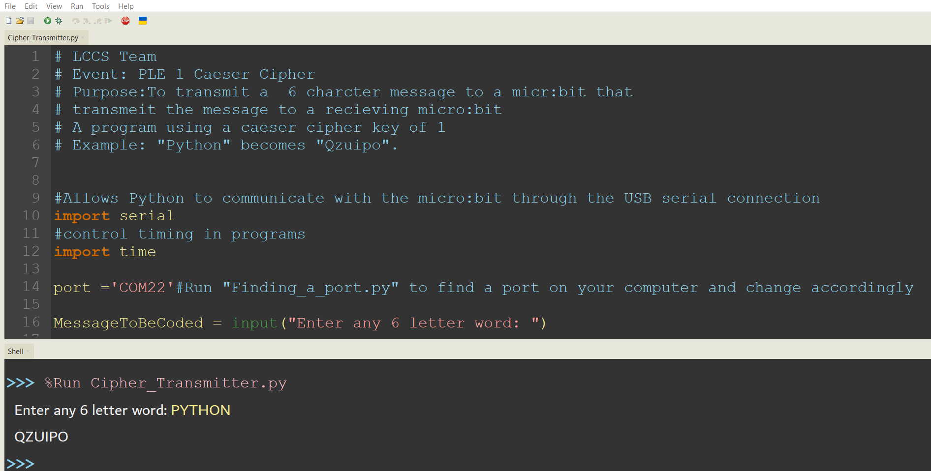

- One the coded message is received by the receiver micro:bit it will send it to the python code for decoding. The original message can be seen in the shell.

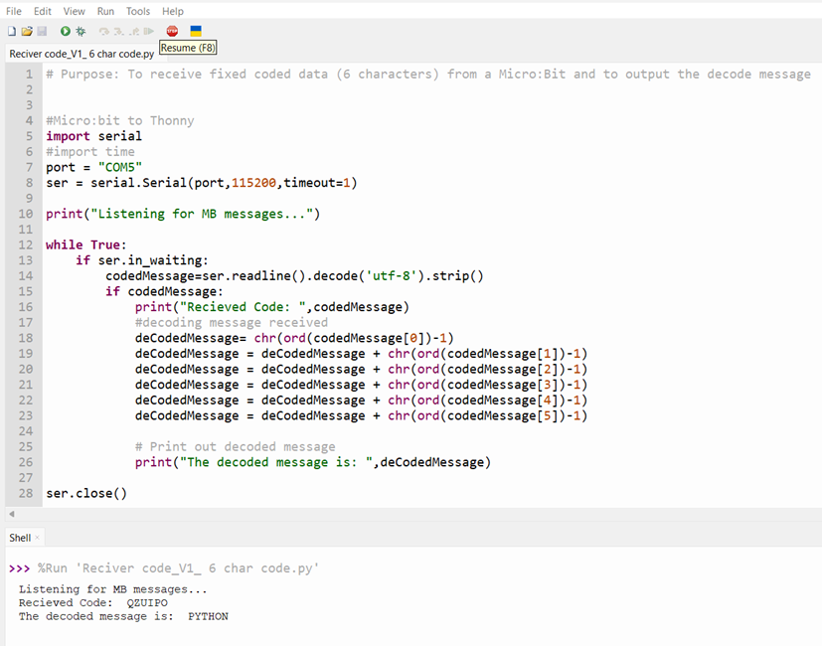
End

